ASEAN-China Agree on Guidelines to Accelerate Negotiations for the Code of Conduct in the South China Sea

Jakarta, 13 July 2023 - ASEAN and the People's Republic of China (PRC) have agreed on Guidelines to accelerate negotiations for the Code of Conduct (COC) in the South China Sea (SCS). The Guidelines were adopted during the meeting between ASEAN Foreign Ministers and the Director of the Foreign Affairs Committee of the Central Committee of the Chinese Communist Party, Wang Yi, in Jakarta (13/7).

Indonesian Foreign Minister Retno Marsudi and Director Wang Yi jointly chaired the meeting. In her opening remarks, Foreign Minister Retno stated that China has been an important partner of ASEAN in maintaining peace, stability, and prosperity in the Indo-Pacific region for over three decades.

Economically, China is ASEAN's largest trading partner, and vice versa. Their trade reaches USD 975 billion. China is also the fourth-largest source of foreign direct investment in ASEAN, with a value of USD 13.8 billion in 2021.

"Our partnership is increasingly important amid growing challenges," said Foreign Minister Retno.

This year marks important milestones in their relationship, including the completion of Guidelines to accelerate effective and substantive COC negotiations, the completion of the second reading of the single draft COC negotiation, and the commemoration of the 20th anniversary of China's accession to the Treaty of Amity and Cooperation (TAC).

"These achievements must continue to build positive momentum to strengthen a partnership that advances the paradigm of inclusivity and openness, respects international law including UNCLOS 1982, and promotes habits of dialogue and collaboration," said Retno.

Both sides must work hard to strengthen this partnership. China must be a reliable partner for ASEAN in nurturing an open and inclusive regional architecture.

"Only then can we achieve win-win cooperation for the sake of peace, stability, and shared prosperity in the Indo-Pacific," said Foreign Minister Retno.

Foreign Minister Retno requested China's support for the concrete implementation of the ASEAN Outlook on the Indo-Pacific (AOIP), including the plan to hold the ASEAN Indo-Pacific Forum (AIPF) in September.

As the Chair, Indonesian Foreign Minister also read out the joint statement of ASEAN. The joint statement highlighted several aspects, including the importance of compliance with the TAC, the adoption of Guidelines to accelerate COC negotiations, support for the implementation of the AOIP, economic cooperation, strengthening health resilience, and people-to-people contact.

Meanwhile, China expressed support for the TAC and ASEAN's centrality in developing an inclusive regional architecture. China also raised several priority areas of cooperation, such as agriculture, the development of electric vehicles, blue economy, and people-to-people contacts.

The meeting encouraged increased ASEAN-China economic cooperation, including the conclusion of negotiations for the Free Trade Agreement (FTA) 3.0, to strengthen trade relations and regional supply chains. The meeting also emphasized the importance of post-pandemic connectivity revitalization, including the realization of China's commitments in regional infrastructure development.

Additionally, the meeting urged cooperation in addressing climate change, including ensuring regional food security, developing new and renewable energy, and welcoming progress in the negotiation process related to the South China Sea.

The meeting adopted the Guidelines for Accelerating the Early Conclusion of an Effective and Substantive COC.

***

For further information, please contact the following:

Director for Information and Media of the Ministry of Foreign Affairs - Hartyo Harkomoyo (+62811831899)

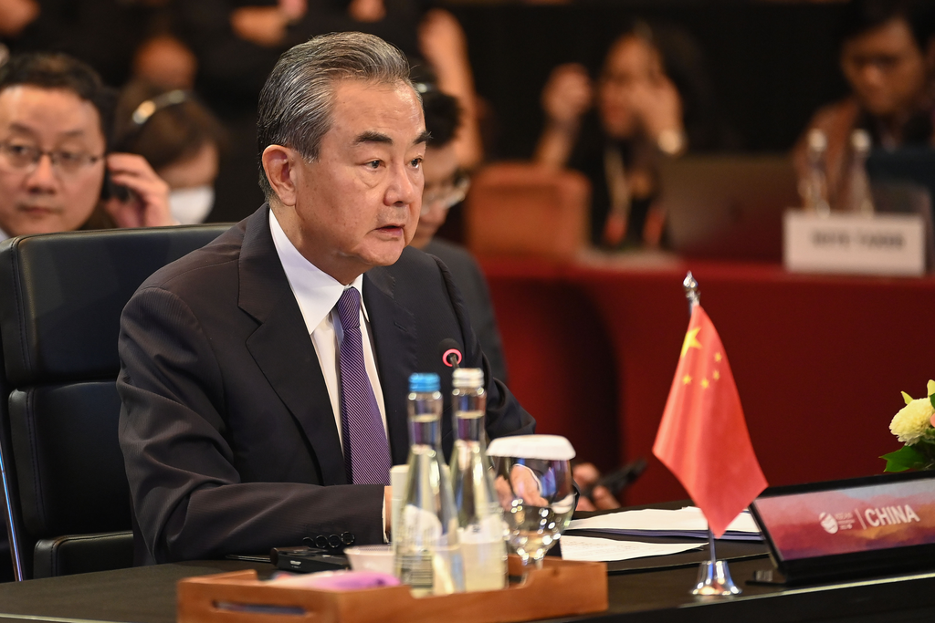

ASEAN and China agreed on Guidelines to accelerate negotiations for the Code of Conduct (COC) in the South China Sea (SCS) during the meeting between ASEAN Foreign Ministers and the Director of the Foreign Affairs Committee of the Central Committee of the Chinese Communist Party, Wang Yi, in Jakarta (13/7) (Photo: Ministry of Foreign Affairs of Indonesia)

